1. Download and install the latest version of Apache JMeter on your system, then launch JMeter and take a screenshot of the running GUI window.
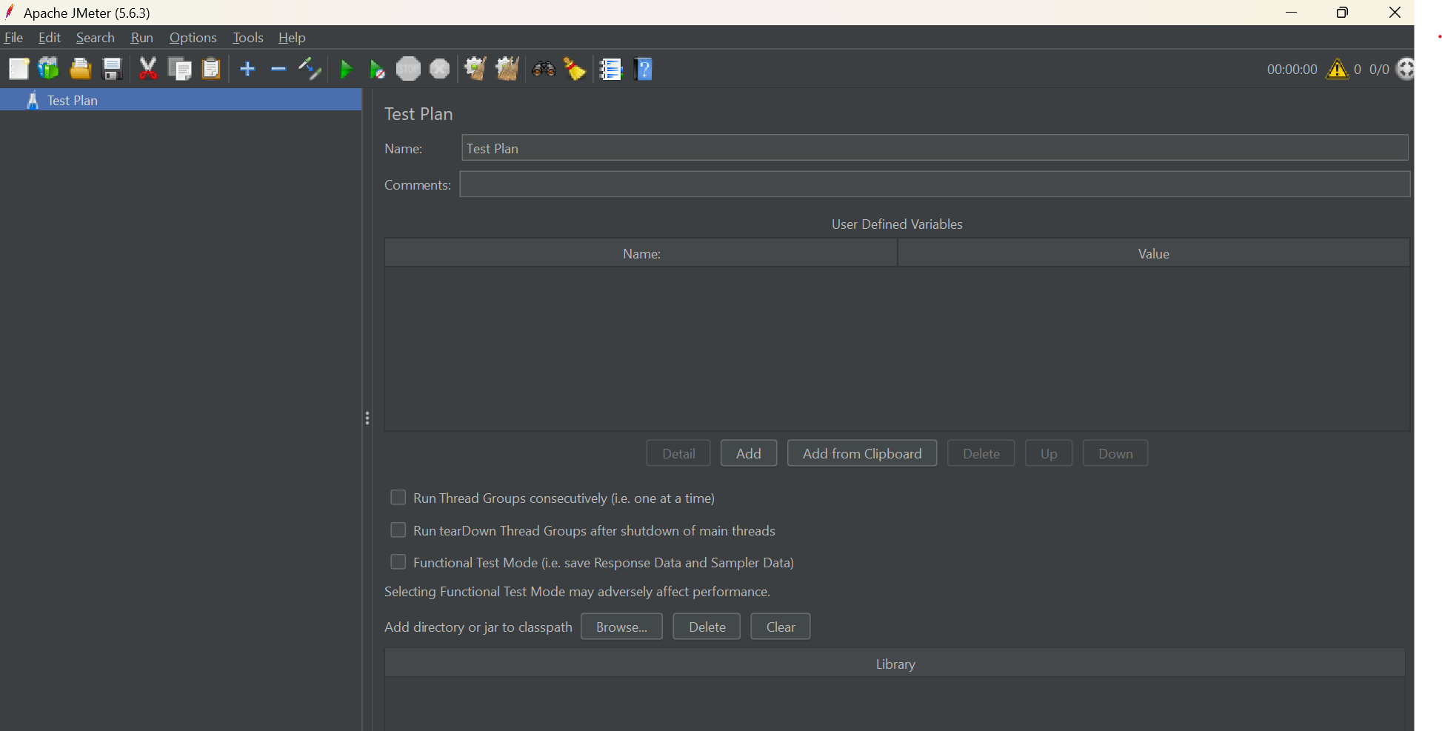
2. Explore the JMeter folder structure after installation and list the purpose of at least 5 key folders or files (for example: bin, docs, extras, lib, printenv).
Folder/File | Purpose
bin | Contains JMeter startup scripts, configuration files, and the main JMeter executable scripts such as jmeter.bat.
docs | Contains JMeter documentation and related documentation files.
extras | Contains additional utilities and supporting resources that aren't part of the core JMeter GUI.
lib | Contains JMeter's Java libraries/JAR files and other libraries required by JMeter.
printable_docs | Contains documentation in printable formats, useful for reference.

3. Create a new Test Plan in JMeter named 'FlipkartSearchTest', add a Thread Group, and inside it add an HTTP Request sampler that points to https://www.flipkart.com. Save your Test Plan as FlipkartSearchTest.jmx.
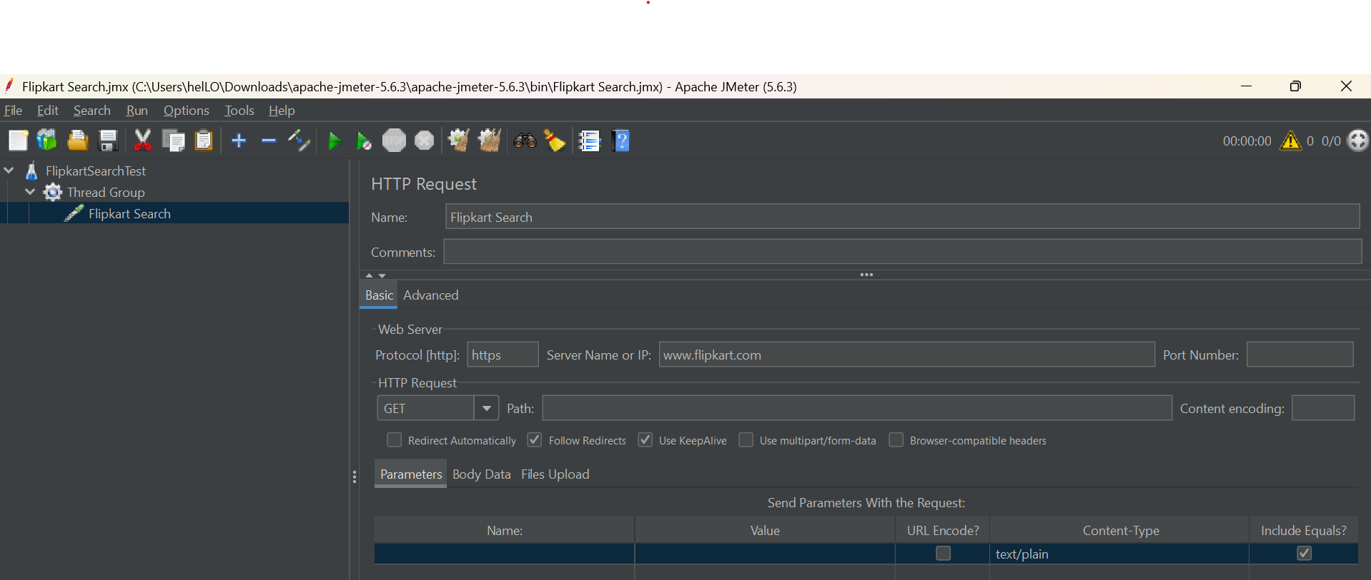

4. Open your FlipkartSearchTest.jmx in JMeter, add a View Results Tree listener under the Thread Group, run the Test Plan, and describe what information you see in the listener after execution. Look for request details, response data, and sampler results.
Request details – GET https://www.flipkart.com/
Response data – HTTP/1.1 200 OK
Sampler results – Thread Name:Thread Group 1-1
Sample Start:2026-09-04 19:20:56 IST
Load time:1536
Connect Time:267
Latency:391
Size in bytes:1264368
Sent bytes:179
Headers size in bytes:2933
Body size in bytes:1261435
Sample Count:1
Error Count:0
Data type ("text"|"bin"|""):text
Response code:200
Response message:OK

